Sania Athar – 24110217
Bushra Kamran – 24110186
Subhan Masood – 22020549
Muhammad Tayyab – 24110342
Hamza Iftikhar – 21100209
Muhammad Ahmed Ehtisham – 24110167

HIK Textiles (PVT) LTD
Group 8 - DISC 231 – S1
2021

Table of Contents
Executive Summary 2
Operational Strategy 2
Forecasting 3
Capacity Planning 5
Process selection and facility layout 7
Job design 11
Location Analysis: 13
Quality management 15
Inventory management 16

Executive Summary
HIK textiles is a medium-level organization comprising 400 employees, managed by a directorate of 4 founding executives. HIK textiles were founded in 2018 by a group of textile professionals; it finds its name from the initials of three of its founding members: Haider, Imran, and Kamran. The organization has a monthly turnover rate of around 9 million. The company’s mission is to earn money for its shareholders and provide a positive working enjoinment to the employees. The prominent feature of the company is to carry out operations while making successful investments to keep afloat in the industry. The company’s vision is to become the leading textile manufacturers in Pakistan by following the best business practices. The company’s operations started by getting a spinning mill on a lease, which was previously shut down for a long time, and running it successfully for the past three years.
HIK Textiles started from a small mill on lease and built an empire from that in only three years; therefore, it serves as an appropriate example of how a small company can grow big due to successful operational management. Additionally, another reason for choosing this company is to analyze its operations and strategies that allowed it to survive and prosper during the pandemic. Since it is evident how disastrous the pandemic was for the economy with so many businesses shutting down and many employees being laid off, this company still managed to earn profits and keep growing during that period. Despite starting with a relatively low financial pool, the firm has managed to improve its equipment and machinery and has also implemented CSR-friendly policies. Consequently, they are Global Organic Textile Standard (GOTS), and Global recycle standard (GRS) registered.

Operational Strategy
Operational strategies translate the strategic goals and long-term product plans into procedures and process that relate to decision making. For HIK, these goals prioritize increasing the organization’s profits by reducing operational costs, while not compromising the superior quality yarn HIK provides to its customers, and to improve the ratio of specialized yarn to that sold as commodity so to improve profitability of the firm further. Moreover, increasing the proportion of specialized yarn, spun according to the specific recipe requirements of the customers, enhances the credibility of HIK in the market while automatically consolidating current and securing further market share. To reduce its costs, both financial and opportunity costs, HIK is moving towards Industry 4.0, which refers to the use of information technology and smart machines that streamline the operational procedures to higher efficiency at reduced costs; HIK aims to develop just-in-time inventory, reducing greatly holding cash and opportunity cost that comes with long-held, idle inventories. Moreover, HIK’s quality control system includes acceptance sampling and process controls, that is testing is done prior, during and after the inputs processed into outputs. Lastly, HIK aspires to expand and enhance its facility layout so to increase the proportion of specialized yarns from 60% to 110%.

Forecasting
HIK relies on the analysis of subjective inputs such as hunches, judgments of the sales staff or managers, and opinions of their retailers while calculating expected demand for future months. They depend upon judgmental forecasts and therefore prefer qualitative forecasts over quantitative forecasts. Qualitative forecasts help HIK become flexible and quick with their forecasts which is crucial for them since they are competing in an industry with high competition. Collecting hard data to prepare accurate forecasts can be a time-consuming task, and they must make quick decisions and act timely to compete in the industry. Another advantage of qualitative forecasts is that they can offer powerful insights which might not be found through the analysis of historical data. Opinions from experts or surveying consumers present HIK a chance to improve their products and to gauge the consumer interest and demand of their products to reduce error in forecasts. However, qualitative forecasts are based on the intuition of the people involved in producing forecasts. This approach is prone to human errors as it is subjective. Moreover, there is a high risk of bias creeping into qualitative forecasts. The sales team of HIK might be a bit too optimistic while judging demand during their visits to the market, which can result in high holding costs for the firm, and in some cases, the team might underestimate the demand, which can cause shortages and damage the repute of HIK. Preparing quantitative forecasts along with qualitative forecasts can help HIK to better predict future demands, which would significantly reduce the risk of shortages and excess supply. Quantitative forecasts would allow HIK to analyze historical data to capture out any trends or variations during specific months, which might not be possible through qualitative data used by HIK currently. Therefore, it will aid HIK in correcting a significant weakness in their planning process.
The two-year data provided by HIK did not display any significant trends; However, the graph shows us that there were some big variations in the data as indicated by the big spikes and dips in the graph. Even though applying the naïve method gives us a better MAD, MSE, and MAPE (refer to excel forecasting sheet) value as compared to the current forecasting done by HIK, the forecast can still be improved by averaging out the huge variations, which would give a better and more accurate forecast. To achieve this, three months moving average was applied. Using a three-month moving average will allow HIK to average the variation in its data while also allowing it to stay responsive to changes in demand. Therefore, HIK can become responsive to any changes in the trends, which will allow them to respond swiftly. The mean absolute deviation (MAD), mean squared error (MSE) and the mean absolute percent error (MAPE) had a significant drop after a three-month moving average was applied to forecast the demand for HIK, indicating that the suggested forecasting technique would greatly benefit HIK in determining its future demand. The five-month moving average was not used to forecast demand as it would make the forecasting less responsive to the market changes, which may turn out to be a disadvantage for HIK as they prefer to act quickly and swiftly in their operations to keep an edge over their competition. Using five moving averages made the mean squared error worse than the original forecast, while the MAD and MAPE levels improved. Quick response times due to the use of smaller period moving averages would help HIK to significantly grow their customer base as customers desire quick services along with great quality.

Capacity Planning
Decisions that are related to Capacity Planning are strategic and greatly impact the organization’s ability to meet their predicted long-term demand with their long-term supply capabilities. While it is the company’s natural objective to achieve a balance between both, it is essential for the management to design their facility layout in a way that maximizes the efficiency of outputs being produced.
Currently, the design capacity for HIK is 30 frames, and each frame has 480 spindles. There is an average of 30.4 days that the company uses in its calculation; for each day, there are three shifts. In other words, a total capacity of 1,313,280 spindles per month. As shown in the table below, the number of working frames varies every month, with an average of 23.87 frames for the entire period shown. The table also shows the utilization, which is sufficient during the months of 2019; however, the average utilization ratio decreased in 2020, perhaps due to the COVID-19 irregularity. In normalcy, the utilization for the company is decent.
Capacity Cushion: HIK fulfills the demand orders by producing outputs in batches. Each batch has a specialized yarn, the recipe, and composition of which is precisely and uniquely followed according to the customer’s order. Since there is product variation, HIK maintains a minimum inventory of its outputs. The representative mentioned that outputs produced are sold on a daily basis, with a capacity cushion enough to last 5-7 days. In other words, extra capacity to cope up with demand uncertainty is also sufficient.
It was reported by the company representative that the company produces 60% specialized products – high variation products, on-demand – and 40% commodity type material with relatively lesser variation and predictable demand. This restricts the use of automation to increase capacity efficiency in terms of outputs. Moreover, demand is to a certain extent volatile as most of the demand orders are usually batch-sized or projects. Furthermore, the HIK intends to improve the percentage of specialized products from 60% to 110%, as quoted by the CEO, since the latter is more profitable. Therefore, it is not recommended to increase automation, otherwise the variation in the products would be reduced.
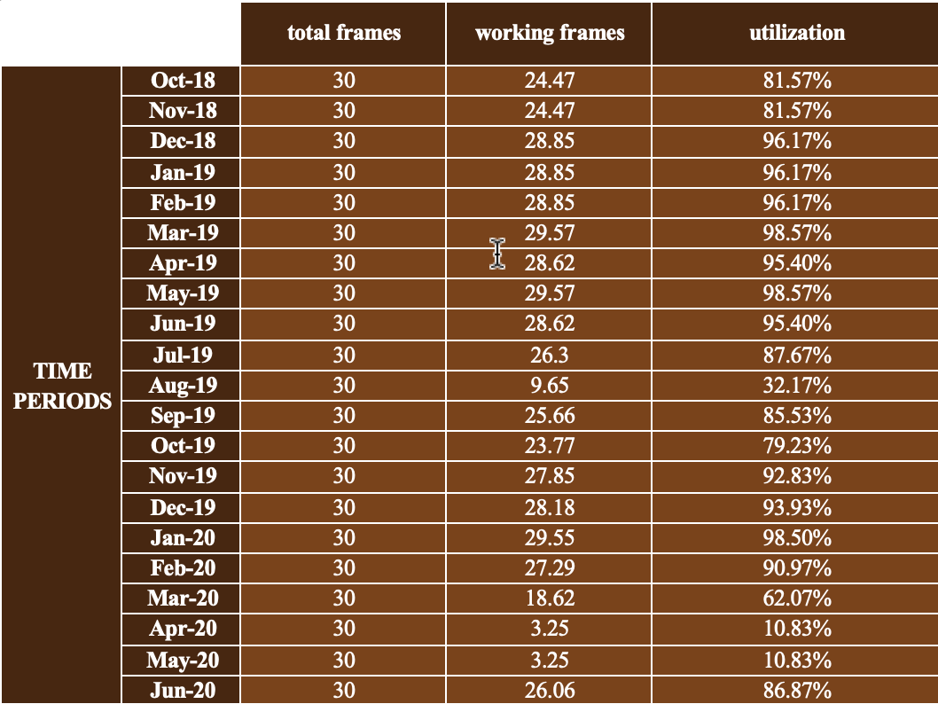
Moreover, expansion of capacity is recommended as HIK is in its growing phase, which means demand is expected to rise. As such, the outputs produced would have to be increased. Since the utilization at normalcy is already at an average of more than 50%, expansion in capacity can help HIK raise from growth towards the maturity phase. Moreover, to produce more specialized products to increase the latter to 110%, the capacity would have to be increased regardless.

Process selection and facility layout
HIK textiles, being a private and a relatively new company in the field, has gained an eye-opening market share and increase in revenue over the years, despite its size. This may be attributed to the position established in the market, which includes catering to a niche customer base, supplying high-quality products (instead of conventional yarn) which are not easily available. The company produces a variety of products, including man-made PV (Polyester, Viscos, 65/1, 36/1, etc.), PC (Polyester cotton, 20/1, 31/1), Polyester synthetic, etc. Since it’s a small company with 14400 spindles and 425 labor personnel, the process is relatively very flexible (less standardization) and is able to incorporate a large number of variations in product type as well as volume. The process to make these products is relatively similar. However, it greatly depends on the type of product in the process, such as the use of different blends for cotton, fancy yarn, simple polyester, etc. For example, when making PC yarn, in contrast to cotton, the mixing process is done separately (called drawing-blending). After that, the carding process is different such that the sliver produced for Cotton and polyester and the cans of fiber, fed into the machine will have specific ratios in the drawing process. Products are made batch-wise, and according to the products, when raw material changes (even for the same products when a different source of raw material is used), the ‘batch’ changes, and the lot numbers are assigned. The workstations are fixed, and the laborers are assigned to their workstations with specific tasks.
Firstly, contracts are made on the amount to be produced on which work orders are produced that contain the exact ratios – how much material to add, the number of bags (quantity) – all of which are given to the GM production. GM production orders their own staff, where orders are received on a daily basis. The work and the processes are allotted accordingly. The first step is in the synthetic blow room, where fiber arrives in the form of bales. Fiber and clusters are opened manually to the maximum. Here the automation starts, where the heap is placed into a bale breaker machine (by the operator), which then goes to the beater where fiber is opened further and made into labs. The output of this department is converted into a suitable form (lab) for the carding (next step) department. The next step, Carding, is the heart of the operation, where quality is determined. All the products are transferred manually between departments through trollies. The desired weight/grain decided in the lab is fed into the carding machine, and a sliver is made. Here, sandwich mixing is employed to ensure least variation and equal distribution of a proportion. Then, the sliver is passed on to drawing machines, where CV (coefficient of variation) is controlled, and blending is done. Since every carding machine passes on its own product, it has to be blended for consistency. Two passage drawing is used (which includes breaker and finisher). Next up, the sliver is now taken to the rowing department, where the sliver is twisted and drafted. Since ring-spun yarn is made at HIK, rowing is a must. After that, the sliver is moved to the next department, the ring hall, where all the costing and production is connected. Finally, the finished product is transferred to the Autocone department, where it is checked and sent for packaging and delivery to the warehouse. Packaging in-charge ensures quality, issues challans and reports, and the products are sent out for delivery. It is noteworthy that quality checks are done after every sub-process.
There is separate labor for the blow room on semi contracts which are based on the volume required. A maintenance department separate from the production department exists that caters to the whole company, assigned according to the requirement of other departments. Different hierarchies exist in various departments according to need, and communication is made smoother through TSM quality, who coordinates all the department heads, ensuring quality and production. Machines are set at specific speeds, and times are allotted to departments according to process requirements through designed formulas. These formulas are based on the percentage of efficiency (embedded into the spin plan) needed at every step. Many conventional formulas and efficiency decisions are also utilized. Furthermore, the layout has been designed with the help of a technical professional (foreign professor) and the company has also received a certification.
After observing the facility in-depth and contacting various managers, it is recommended that instead of keeping a separate hierarchy of managers (like an engineer – foreman – deputy foreman – assistant foreman – helper) for every department, one hierarchy of a general-purpose team be utilized to handle all the department’s needs. This way, one team will handle all the departments as per requirements, working on hourly wage instead of a typical nine-five job, which will save time, energy for the workers as well as a large chunk of cost for the company (since only 12-15 people will need to be employed instead of the current 50-55). New machinery and further automation can be recommended for the company in specific areas such as the mixing process, whereby a huge amount of labor is required on contracts. Hence quality will increase, and the automation will also require less labor reducing costs. Moreover, energy-efficient gadgets such as invertors will help save a sizeable amount of cost for the company. In the daufer process, automation can also be utilized. After consultation with experts and some research and analysis, a conclusion was drawn that the company could save about Rs 6192000/month on labor costing if a Chinese (10-year warranty machine) daufer machine requiring an investment of Rs 10 million was bought (which could also be bought second handed – usually in good condition as claimed by experts). Moreover, the AC units, as observed in the blueprint, may be installed with automatic sensors, detecting temperature and humidity at regular intervals, which would automatically adjust these levels according to process requirements, preventing possible delays and damages. These sensors also save energy as well a good amount of cost on electricity.
I
A B C D E F G H K
J
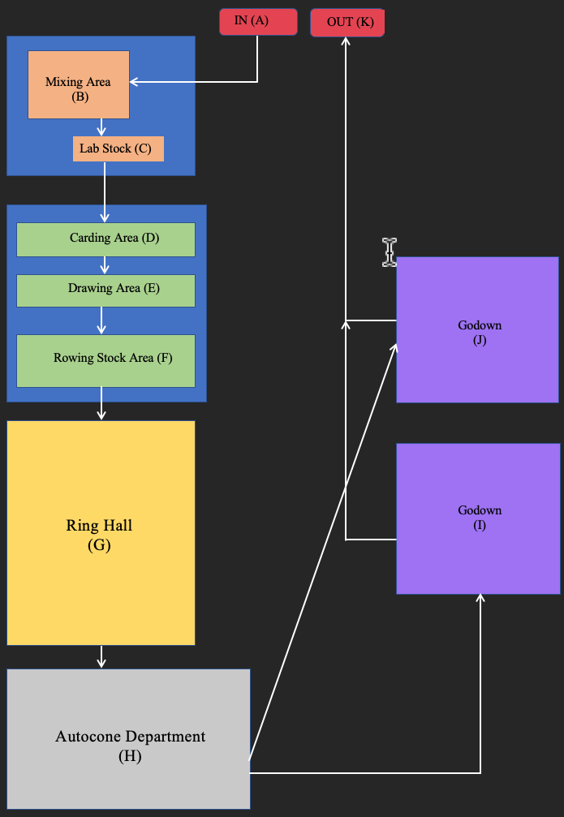
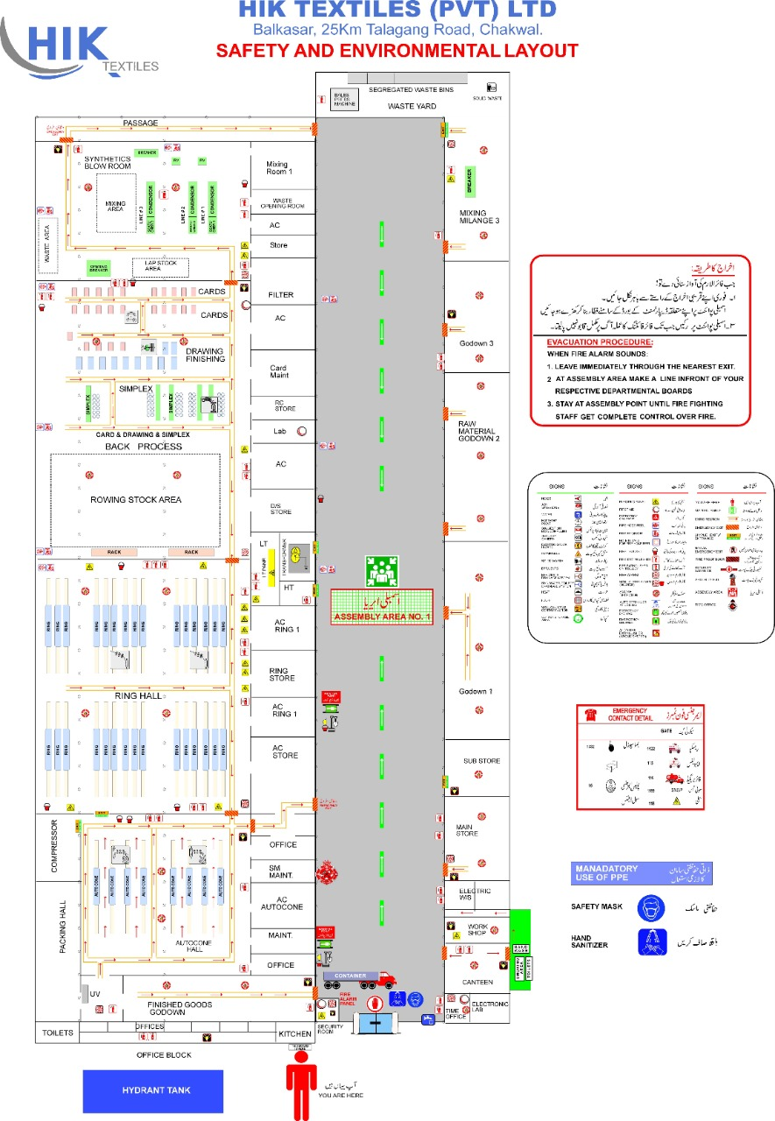

Job design
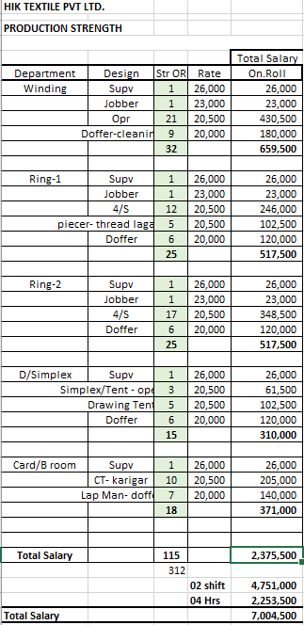
The total employee strength of the organization consists of 423 individuals. These employees have been divided, by the company, into four broad categories namely, production, technical, admin, and maintenance.
Production’s stream is divided into five departments. Each of these departments has one supervisor, one jobber, and multiple dauffers working in the productions, along with specialist staff, the number of which varies in line with each department’s specific need. As the departments under productions work in three shifts, two shifts with back-processing and one without, the staff of all three shifts adds up to 312 employees. In the productions, the highest salary is that of the supervisor, which is PKR 26,000, while the lowest salary is PKR 20,500. The lowest salary of PKR 20,500 is in line with the minimum wage set by the Government of Punjab. Total salary expenses of productions are PKR 7,004,500.

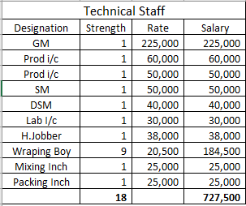
The technical team consists of 18 employees, including a variety of jobs from the general manager, being paid the highest salary, down to the minimum wage-earning wrapping boy. The technical staff aids the rest of the departments through an overview of operations within the organization. Total salaries of the technical staff add up to PKR 727,500.
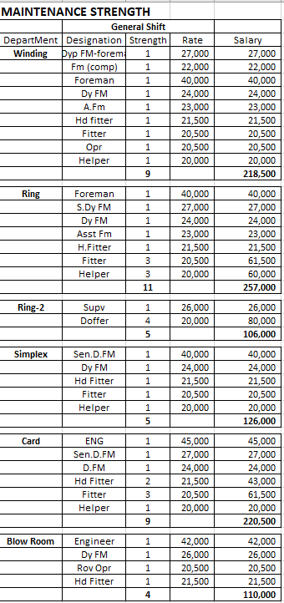
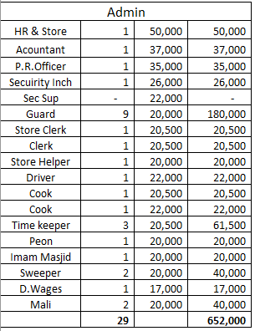
Administration staff of the organization comprises a total of 29 employees. Most employees are service providers to the company, and their salaries range from PKR 20,500 to PKR 50,000. PKR 652,000 are the total monthly salaries paid to the admin staff.

The maintenance stream of employees is the second biggest in terms of strength, after productions. There is a separate maintenance team for each department as per their adequate needs, which sum up to a figure of 64 employees. From maintenance, the highest paid are the engineers with a monthly salary of PKR 45,000, while the government-set minimum wage of PKR 20,500 is the lowest monthly salary paid.
Employees under maintenance, work in a single general shift. Total salary expenses on these 64 employees are PKR 1,557,500.

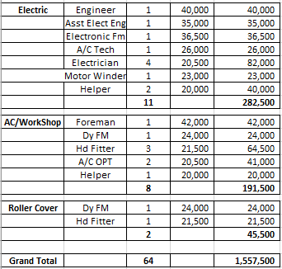

The employee strength in each department is decided as per the needs of its operations and may also vary with demand. For instance, if the average count of the textile mill is more towards the courser side, then the total production is more, and hence, a larger quantity of labor is required in the productions and maintenance. Similarly, if the count is more towards the fine side, then the mill has the capacity to shut down the back-process, and consequently a smaller number of employees would be needed by the company.
Total salary expenses of the company’s employees are PKR 9,941,500, for each month. Apart from market competitiveness, salaries are subject to the skill and experience of the employee, as well as the need of the company for that particular occupation. As a trend, specialist workers such as engineers have higher salaries set in the company as compared to generalist workers such as machine operating labor. In terms of fringe benefits, employees are provided with residence by the company, as well as all utility bills. In addition, one time dinner is provided by the company to its employees. Apart from the once-a-week holiday, employees are given 14 days of leave per year as per the government of Punjab guidelines.

Location Analysis:
The choice of location plays a huge role in the success of an organization and is very closely related to an organization’s strategy ^{[1]}. Some organizations tend to reduce the transportation costs by setting up in places where raw materials are easily available, while others try to cash in on availability to their customers in order to maximize sales. Hence the location can make a lot of difference on the operations and therefore this decision needs to be aligned with the company’s strategy and mission. A poor choice of location might result in excessive transportation costs, a shortage of qualified labor, loss of competitive advantage, inadequate supplies of raw materials, or some similar condition that is detrimental to operations^{[2]}. Some of the important questions that can help in deciding a location include:
- Does the location have potential market for the product/service the organization is providing?
- Would this location be feasible for the customers?
- Would choosing this particular location help with production of products?
- Are raw materials easily available? If not, then are transport costs feasible?
- Is the supply chain reliable and easily manageable?
- Can availability of labor be ensured in this particular location?
- Are political, environmental, and ethical factors favorable in the location under consideration?
Now let’s look into why HIK Textiles Pvt. Ltd. decided to set up their unit in Chakwal, Punjab and what factors were involved in this decision. One of the major reasons was the availability of a unit which was perfect for their operation. For a new company, a place where they can easily carry out their operations and manufacture their products at a relatively low cost can make a huge difference. Hence the availability of unit was taken into consideration when deciding upon the location. Another reason why this unit was chosen is that the unit ensured flexibility which aligns perfectly with HIK Textiles Pvt. Ltd. and their business model as they place a high emphasis on flexibility among their products. This also meant that the unit did not need to have a lot of automated machines, hence reducing the initial cost of setting up the unit.
Secondly, HIK Textiles Pvt. Ltd., like many other organizations, depends on its labor force. In order to compete against the more established organizations such as Nishat and Sapphire Textile Mills, they needed to provide some sort of incentive to its labor force. This incentive was that the unit of HIK Textiles Pvt. Ltd. was located in Chakwal which is a central location for most of their labor force. Most of the organization’s workforce comprises people coming from areas such as Chakwal, Mianwali and Sialkot. This helped them gain a reliable manufacturing and productions team which ensures that there are no problems faced during the production phase. A set of highly talented and motivated individuals results in a productive work environment leading to higher efficiency in manufacturing products leading to more business for the organization.
Another key factor for HIK Textiles in their choice of location was availability of raw materials. Punjab is famous for producing high quality, heat resistant cotton at a high yield. Punjab is said to produce almost 70% of the entire cotton available in an agricultural country like Pakistan ^{[3]}. This means that cotton is available at a low cost and transportation costs are also minimized since the unit is located in Punjab itself. Government Policies in Punjab also favor the growth of cotton in Punjab making Punjab an ideal location for a textile producing organization. As a result, the overall cost of operations is reduced, while maintaining the high standards of the organization. This also makes supply chain management easier as there are a lot of suppliers available ensuring that raw materials are always readily available for the productions team. Since, there is an abundance of suppliers, the risks are relatively low if a certain supplier is unable to cope with the demands.
All these reasons and factors were taken into consideration by the upper hierarchy of HIK Textiles before they decided to set up their unit in Chakwal, Punjab. This choice of location makes sense from a strategic and marketing point of view for the organization. They were able to set up a successful unit in a place where the market had relatively less competitors and managed to keep their costs to a minimum facilitating their business model and increasing their sales.

Quality management
Quality is the utmost requirement of the customer as well as of the producer. The sales and popularity of the product depends on the quality of the product. It is often assumed that better quality means high price, however, it is on the company to produce better quality while also maintaining their budget.
The production of HIK’s specialized products production occur in a batch of approximately 500 products. The products include polyester viscose, which is the most running product, cotton and viscose. To maintain the desired level of quality, HIK has incorporated the use of physical surveys, quality monitors and USTER tests. The company did not just come up with the ‘level of quality’ they want to produce themselves, rather they went out into the real market to conduct physical surveys and interviews.
Interviews regarding the desired quality of buyers, and what products they require the most, were conducted. Moreover, quality monitors ensure that quality is being maintained during the production processes. USTER tests properly measure the evenness of the diameter and thickness of the yarns. Daily production targets are set but still the importance is given to quality in every batch.
Furthermore, before the production starts, sample-based testing is conducted, and it is passed through all the quality checks to ensure that the quality is maintained in the batch production as well. To detect faults, quality monitor sensors are installed in each department to remove faults during the production so that problems do not arise after the whole batch is made. In addition to this, HIK is a social and quality compliant company.
However, a problem with the quality monitor sensors is that they might not work properly due to variation in voltages. This will result in failure of detecting faulty products. Another problem is that the grid station is located very far away from the mills, thus changes in environmental conditions might affect the transfer of power.

Inventory management
The company incorporates just-in-time (JIT) policy for inventory control and management. No costs are incurred in storing inventory and spare parts for the production, rather management finds it more suitable to invest the finances somewhere else. At the start of the month, inventory is ordered for the whole month. HIK finds it more beneficial to invest money into research and development which results in greater return on investment.
While ordering inventory, the situation of cashflows and liquidity ratios is also taken into consideration.
Quick Ratio = (Current Assets – Inventory)/ Current Liabilities
The IMS system of HIK is complex yet properly functional. It thoroughly covers different aspects of the company and ensures all of them are working efficiently, individually and collectively. However, benefits and problems come hand in hand. One problem is that of the loan and advance salary policy. The finances are affected greatly when the company gives out loans and advance salaries. Moreover, the company is divided into smaller departments due to which the employees only work in their own departments and fail to operate as one complete department. Although smaller departments might result in greater efficiency but employees not being a single unit can lead to even major problems. This is a part of environmental management system which disturbs the environment of the whole company. It can be eradicated if company operates as a single entity and all the departments help each other out in the case of difficulty. The mills are the cause of noise pollution, which can damage the auditory perception of the employees. For this reason, special ear buds are provided by the company every week.

Bibliography
Stevenson, William J, Operations Management, 13th Edition, Page 343.
Stevenson, William J, Operations Management, 13th Edition, Page 344.
https://aari.punjab.gov.pk/crop_varieties_cotton

